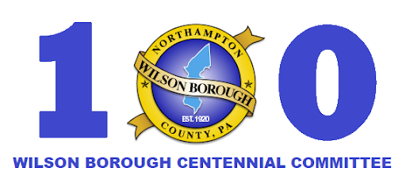

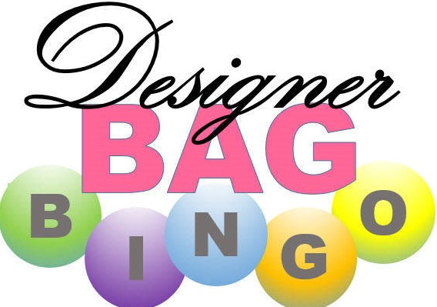
Wilson Borough Centennial Committee
Saturday June 22, 2019
Strausser Community Center
2210 Northampton St - Easton, Pa 18042
Doors open at 10:30am Bingo starts at 12pm
Tickets are $20 in advance $25 at the door
Ticket sales are limited to 180 tickets
Please contact Holly Waugh @ wilsonboro100@gmail.com or Jeanne Jones @ nannylillian1@yahoo.com for advance tickets
Tricky tray, food and bake sale and a 50/50 drawing will also be available.

