SLF material giveaway runs from May 15th
to October 1st (or until supplies run out)
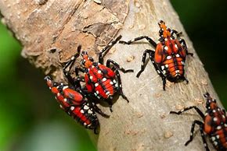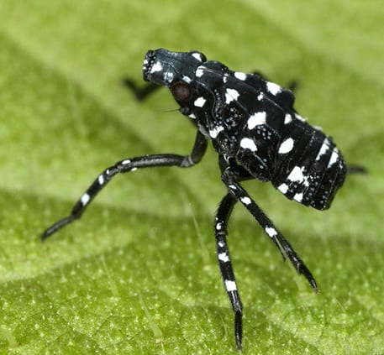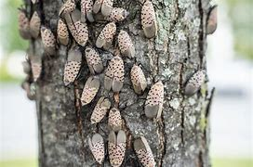
For more information or to arrange a pickup date/time please use the contact information below.

Contact Name: Dion Campbell
NCCD District Manager
Phone: 610-829-6284
Email: dcampbell@norcopa.gov
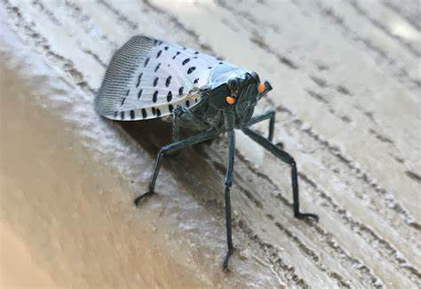As the warm weather arrives, the Spotted Lanternfly will once again be hatching out to cause havoc in our county.
No need to worry, NCCD is happy to once again offer banding materials to county residents. The cost is free. All you need to do is call or email and request supplies. Once the request is received, a date and time will be provided for pick up at the conservation district office located at:

14 Gracedale Avenue, Nazareth
(Greystone Building).

NOTE: All pickups must be pre-arranged. Walk-ins will NOT be accommodated.

**Identification is required**

Northampton County
Conservation District

