


















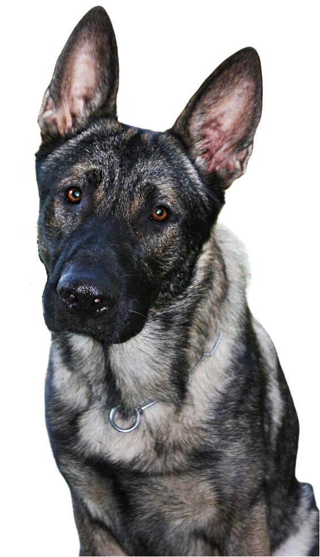
WITHOUT IDENTIFICATION,
A LOST DOG MAY NEVER
MAKE IT HOME.

Failure to have your dog licensed may result in a fine of up to $500 plus court costs.
All dogs must be licensed when you buy or adopt them (earliest is 8 weeks old) or 3 months of age, whichever comes first, by Jan. 1 of each year.
Your best friend’s best chance
to make it home safely is to be properly licensed.
How much does a license cost?

Annual Licenses . . . . . . . . . . . . . . . . . . . . . . . . . . . . . . . . $10.80
Lifetime Licenses . . . . . . . . . . . . . . . . .. . . . . . . . . . . . . $52.80

Senior Citizens or Residents with Disabilities:
Annual Licenses . . . . . . . . . . . . . . . . . . . . . . . . . . . . . . . . $8.80
Lifetime Licenses . . . . . . . . . . . . . . . . . . . . . . . . . . . . . $36.80

Licenses can be obtained through your County Treasurer.



How to apply for
a Dog License
Online:
https://www.padoglicense.com

Northampton County Treasurer
Address: 669 Washington Street
Easton, PA 18042
610-829-6186


For more information, contact the
PA Department of Agriculture at:
717.787.3062

